Evaluation of voice command + HiveMQ part of the project together.

For evaluation we recorded some values and data for two different evaluation scenarios, quiet and noisy. Time data that we recorded for the script were the loop() and the setup() methods. Recording loop() tells us basically how long it takes for the script to detect voice, analyze the audio data, execute voice command and send it to the cloud. And secondly timing the setup() method, tells us how long the system takes to set up. That means for example setting up the pins and connecting to the wifi. Then we also saved data for voice command succession rates.

Below is the data for voice command recognition success rates for noisy and quiet environments:

Quiet environment:

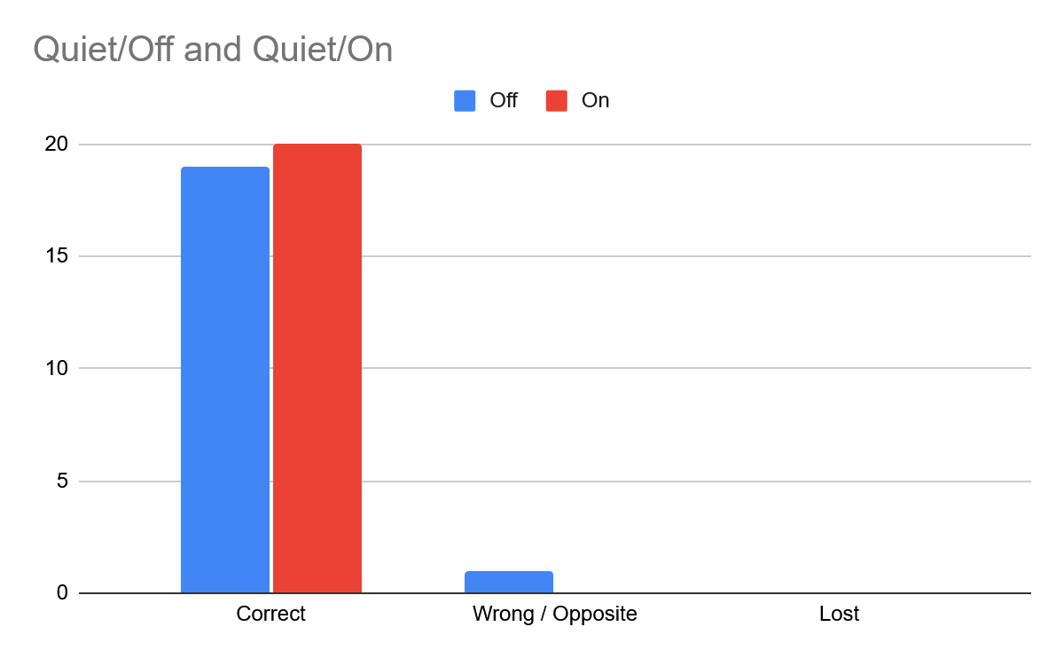

As you can see, in a quiet setting, the voice commands worked almost perfectly. We had 19 successful off commands, and 20 successful on commands. Only 1 off command was registered as an “on” command.

Noisy environment:
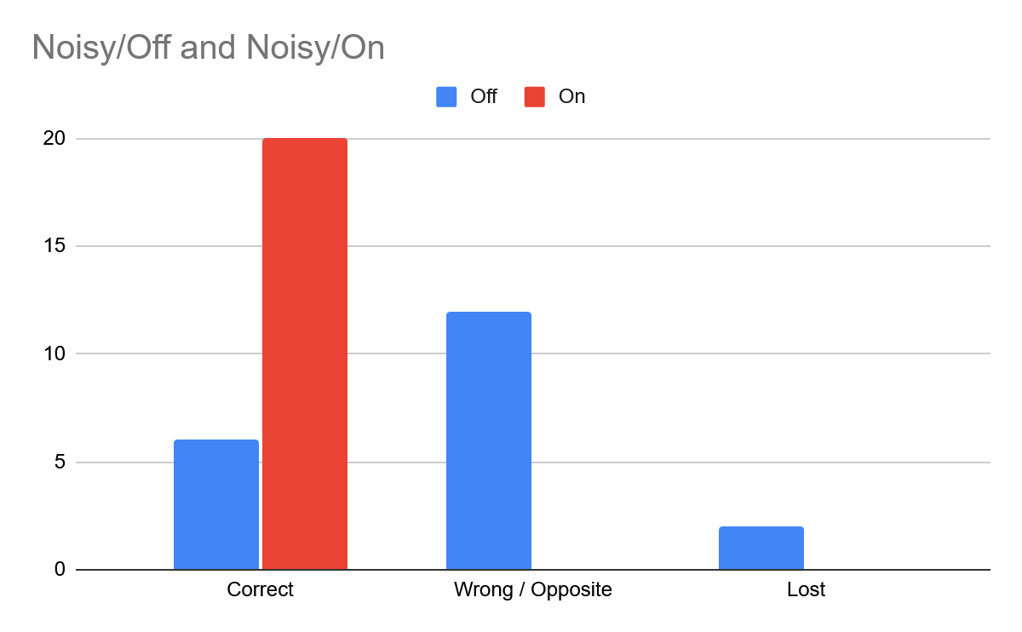

In noisy settings however, we can see that it was a lot harder for the “off” command to work properly in the script. The on command still worked fabulously throughout the noisy environment with a 100% succession rate on the commands. But for the off command, only 6 commands were registered correctly as “off” and the rest either were lost (2) or they were wrongly calculated as “on” commands.

Sometimes some random audio noise would be calculated as one of the commands (on or off) by the trained model. This happened rarely but it sometimes did happen, so this was one of the ways the script got wrong commands.

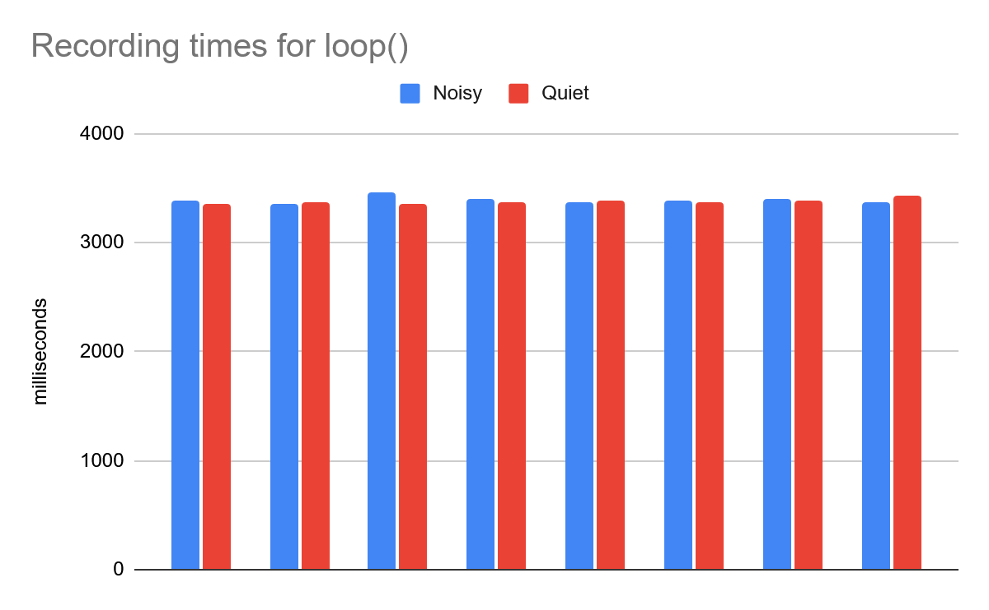
For the loop() method, It usually took around 3.3 to 3.4 seconds to run it. Times were the same despite the environment and this was expected.

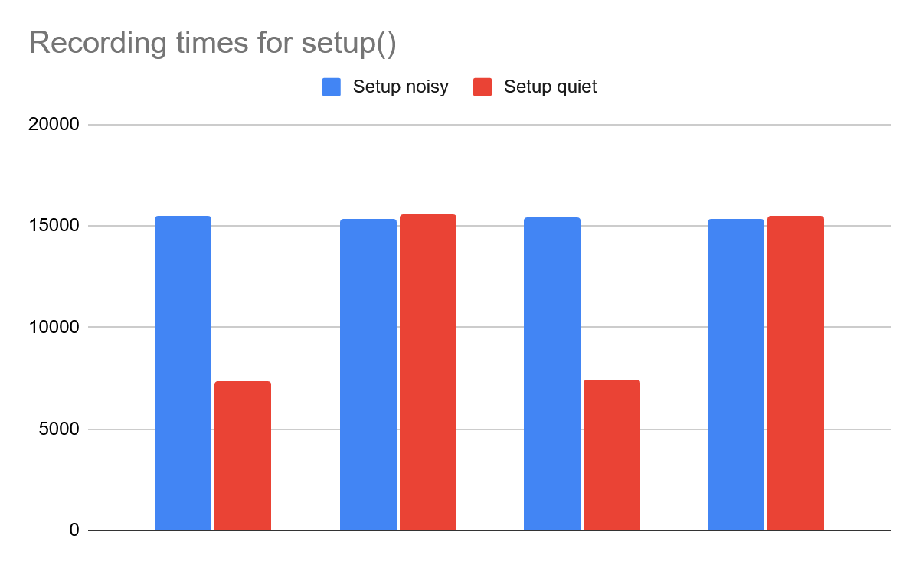

For the setup() method, it usually took around 7 or around 15 seconds to run it. Most often it took around 15 seconds to run the setup() method, but there were times when it only took around 7 seconds. The funny thing about these stats is that the quick 7 seconds start ups happened only in the quiet environments. Noise should not have had this much of an impact on recording times and thus we think that the limited size of the data makes it seem the environment has a big impact on recording times.

We timed the loop() method around 18 times and the setup() method only around 8 times. There were times when the connection to wifi did not work and the script got stuck waiting for the connection to the wifi. It was quite annoying but the script still worked despite this flaw.

